

**Deakin University**

CSIRO

Project Handover

19/05/2019

Project Sponsor

CSIRO

Project Team

Team 1

Degala Anurag Yadav, 218556205

Harsha Lakshmipuram, 217443682

Amelia Wigg, 213123121

Malayamarutrham Sai Pradmuna, 218580724

Sai Gautam Mandapati, 218602266

Pavani Gujjarlapudi, 218431365

Eswar Sai Krishna Gowra, 218522364

Tarindhu Chamara, 218310312

# Purpose

This document defines the transfer of all relevant information and artefacts produced during the course of SIT764. With this document, a new member should be able to identify all key aspects and artefacts of the project and have access to key systems or configurations.

# Project Description

The project aim is to design a text annotation tool that allows the user to easily get a definition of a word that may have complex or multiple meanings, quickly.

As stated in the Market Research Document our aims are:

* *To develop a web service that annotates text with definitions, taken from controlled online vocabulary services.*
* *Make it easier, simpler and more accurate to get a definition, which has been provided by a collaboration of online vocabulary services.*
* *A quick understanding which is enabled by hyperlinking technical terms to their corresponding definitions.*

Our Deliverables involve a tool to:

* *Detect words or phrases with in a text that have definitions in one or more source vocabularies*
* *Allow the user to select which definition applies to the usage of the term in the context*
* *Allow the user to select an alternate or preferred term to replace the original*
* *Insert a hyperlink to the definition*

# Artefacts List

This table should clearly identify each artefact to be part of the handover. This includes but is not limited to:

* Market Research Document
* Design Document

GitHub and code

* SharePoint

|  |  |  |  |  |
| --- | --- | --- | --- | --- |
| **Artefact Name** | **Artefact Type** | **Revision No** | **Notes** | **Link** |
| Market Research Document | Document | 1 | Market research document sent to supervisor and client during the last week. | <https://deakin365.sharepoint.com/:w:/r/sites/CSIROGroup1/_layouts/15/Doc.aspx?sourcedoc={4F99A512-1841-4F61-9A25-913B44FFCA08}&file=Market%20Research%20Final.docx&action=default&mobileredirect=true&DefaultItemOpen=1> |
| Design Document | Document | 1 | Market research document sent to supervisor and client during the last week. | <https://deakin365.sharepoint.com/:w:/r/sites/CSIROGroup1/_layouts/15/Doc.aspx?sourcedoc=%7BC1BA92C0-3711-47BE-B591-C1552D050D3A%7D&file=Design%20Document.docx&action=default&mobileredirect=true> |
| GitHub and code | Link | 1 | Implemented the basic code using java script and HTML with Jason . | <https://github.com/Adegala/squad-1> |
| SharePoint | Link | 1 | SharePoint has all the document and other technical images with presentation slides. | <https://deakin365.sharepoint.com/sites/CSIROGroup1> |
| Design document presentation | PowerPoint | 1 | Final presentation of the design | <https://deakin365.sharepoint.com/:p:/r/sites/CSIROGroup1/_layouts/15/Doc.aspx?sourcedoc=%7B1C9C8D18-C1B1-4663-9E11-780868D00A56%7D&file=Design%20Document%20Presentation.pptx&action=edit&mobileredirect=true> |
| Trello Board | Link | 1 | Trello board used to maintain and assign user story in every sprint | <https://trello.com/b/FwfPTG3w/csiro-squad-1> |
| Slack Channel | Link | 1 | Slack channel used for communication | <https://deakin-industry-2019.slack.com/messages/CHB464QGN/details/> |
| Presentation | PowerPoint | 1 | Final presentation of all the sprint outcomes and overall achievement of Csiro 1 | <https://deakin365.sharepoint.com/:p:/r/sites/CSIROGroup1/_layouts/15/Doc.aspx?sourcedoc=%7BA64007C9-4063-43C0-9385-3ECEF59F0EB6%7D&file=CSIRO%20presentation.pptx&action=edit&mobileredirect=true> |

# Business Features

Provide a detailed list of features which are implemented. Ensure you indicate if a feature has been approved by the client or not, which sprint a feature is part of, features which are still in progress. Refer to your Trello board here. Add a snapshot of your Trello board in the handover delivery package.

|  |  |  |  |
| --- | --- | --- | --- |
| **Feature** | **Client Sign-Off State** | **State** | **Notes** |
| Authentication | Signed off 2017-03-07 | Final | SSO Authentication not completed in this scope. |
|  |  |  |  |
|  |  |  |  |
|  |  |  |  |

# Planned Work

**Sprint Planning:**

**Sprint one:**

Goals:

The Goal of Sprint one Is to provide

* Project Scope document
* Infrastructure document
* Complete market research
* Project proposal

Outcomes:

* Infrastructure document was done and Supervisor adviced to provide complete non-manual market research
* We came to know about many competitors and similar tools to which we are developing

**Sprint Two:**

Goals:

# Open Issues

Provide a list of any ongoing and open issues or challenges, and how you plan on addressing each challenge in the following sprint.

* Development team to not have access to testing server, therefore we cannot test new versions of the codebase – we will contact client ASAP to request access.

# Lessons Learned

* We learnt a range of different programming languages including JavaScript, node.js, html and CSS and the difficulties of application with minimal experience
* We learnt about the need to have a testing environment for our code/project
* We learnt about the client's desire to build technology upon the already existing capabilities of BioPortal
* We learnt that SharePoint is an excellent way to share documents (as Deakin students) and GitHub is better for sharing code
* We learnt that Lynda is an excellent platform for upskilling, but works best in conjunction with other resources

# High-level architecture of the product

* Depending on the project: Please provide some sort of a high-level architecture of your project highlighting the key components of the project and how they integrate/talk to each other.
* Please provide any necessary deployment details.
* Please provide detailed set up instructions for the development and/or testing environment(s) – I.e tools/IDEs/scripts/ etc.

# User Manual

* The user enters the URL of our website in the search bar and then this page is displayed.

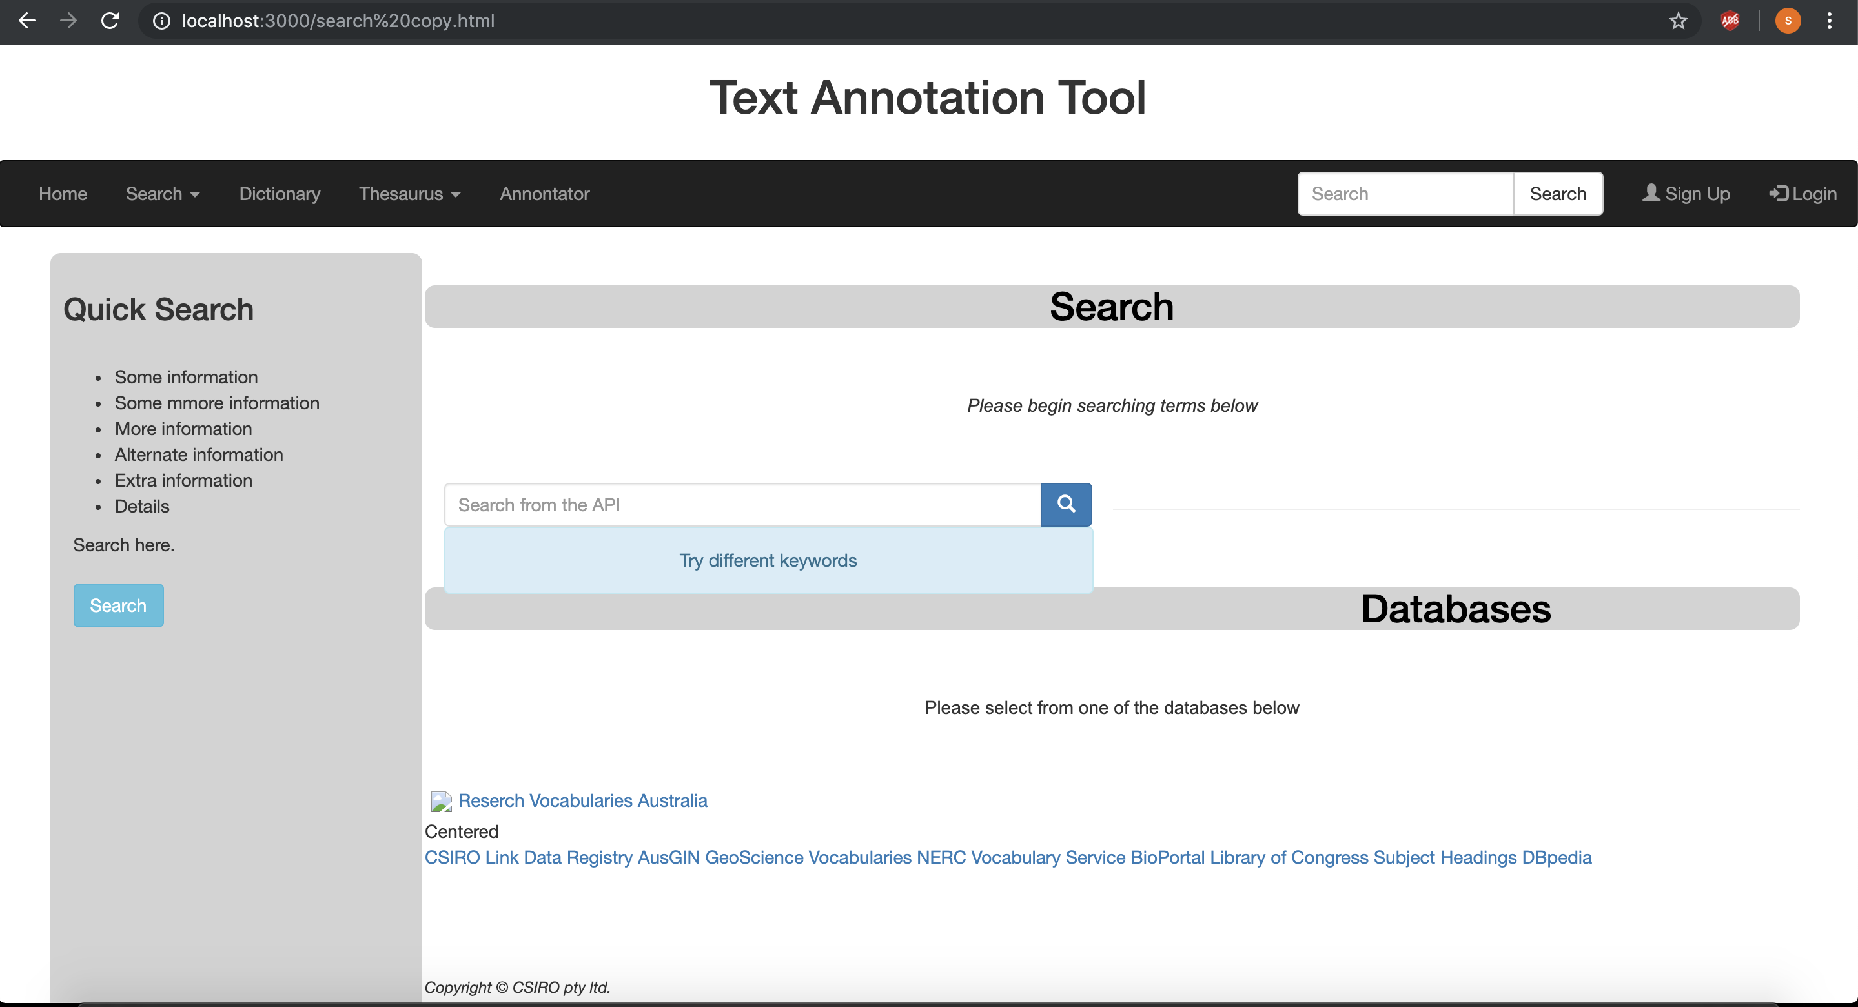

* The next step the user can do is he can search for different keywords by typing the words into the search box.

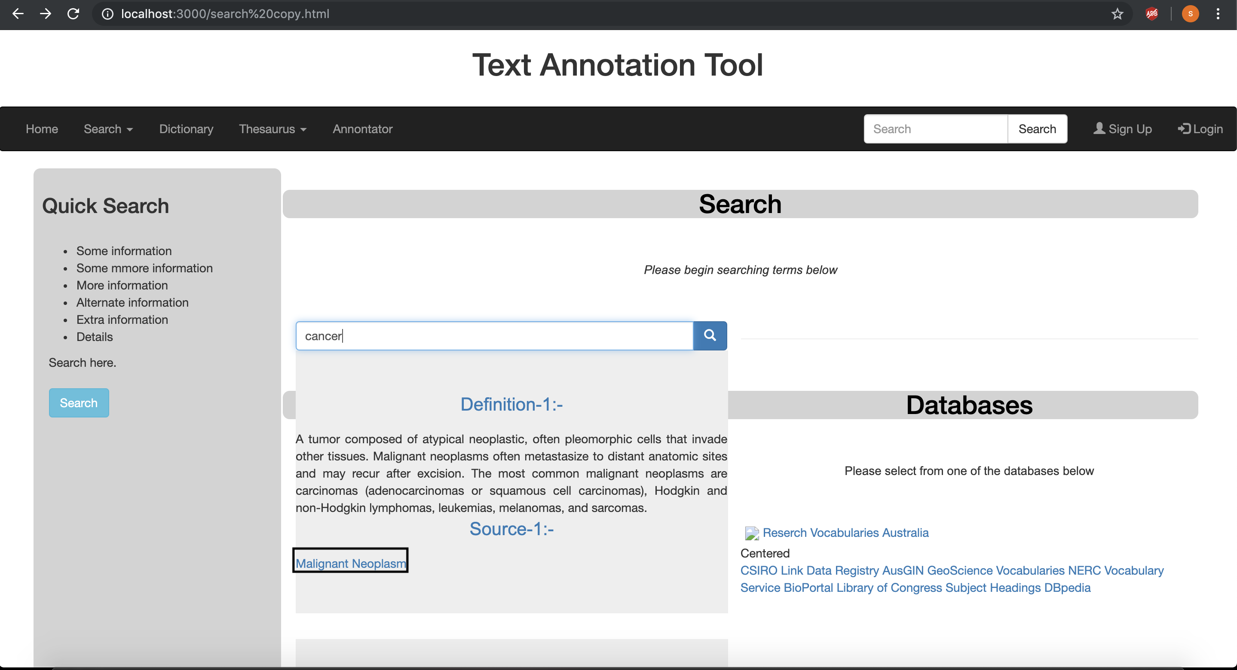

* The user when clicked on the highlighted box that will take the user to the bio portal where he can have a detailed description of the word for the ontology.

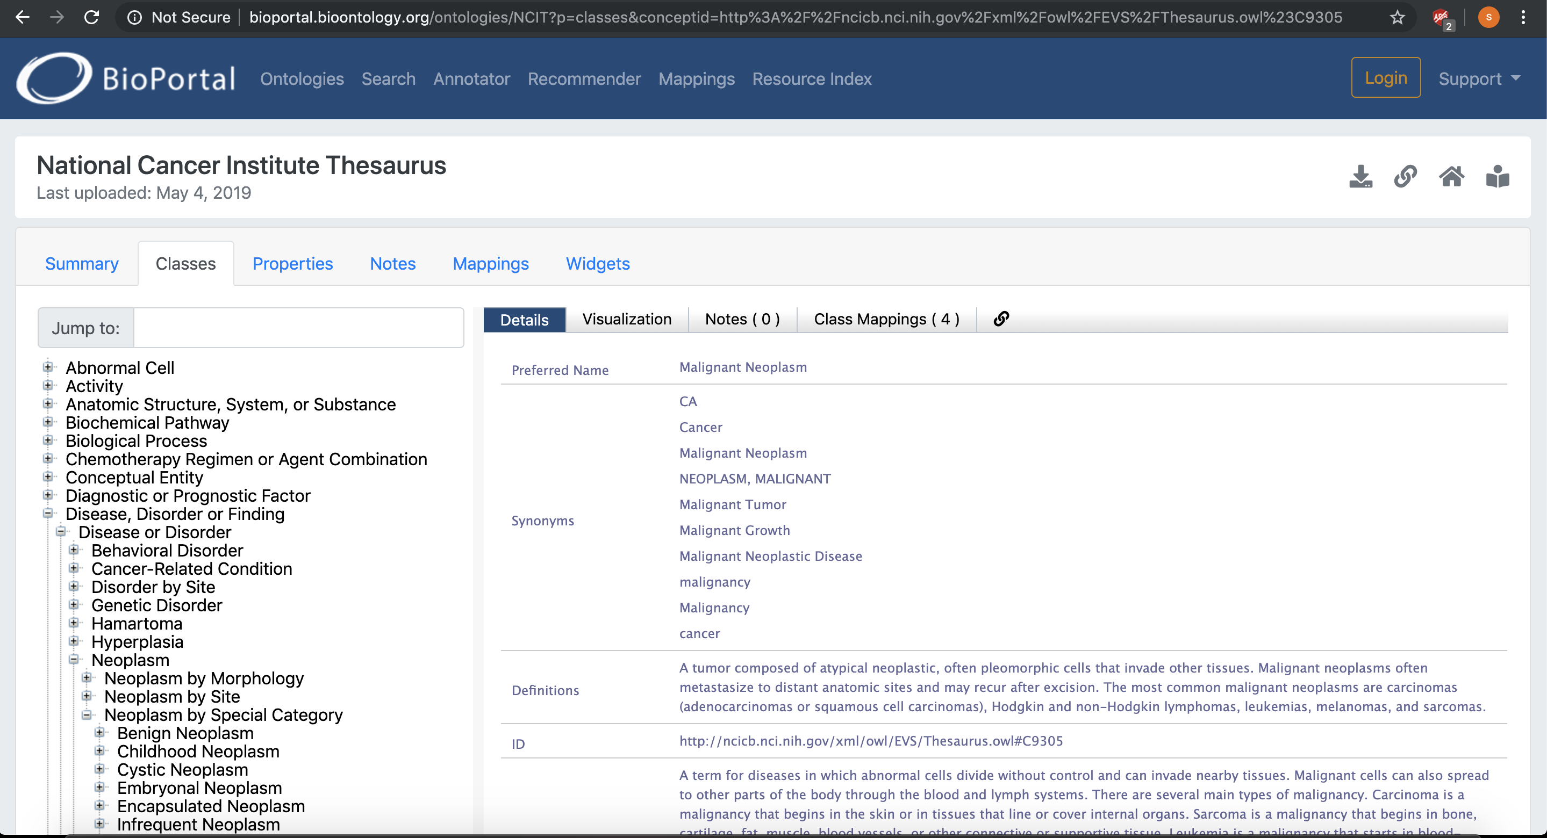

* Therefore, by following the above steps the user can successfully find the annotations for the words.
* In the coming updates we will be providing an advance search for the users and an option of creating an account for the user where he can save the words for future use.

# Other Documents

Please include any appendices or other relevant documents not covered in the above sections, for all artefacts delivered during the course of the project.

# Sign-off

We <team members>, have included all relevant material which is agreed to be included in this handover. If an artefact is not included, it is stipulated in the Planned Work section, or artefacts list.

Date:

__________________________________________

Signed

__________________________________________